JSP expression tag->

* The code placed within **JSP expression tag** is *written to the output stream of the response*.

*So you need not write out.print() to write data. It is mainly used to print the values of variable or method.

### **Syntax of JSP expression tag->**

1. **<**%=  statement %**>**

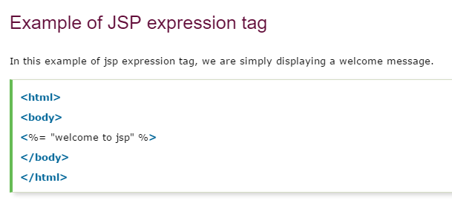

# JSP Declaration Tag->

# The **JSP declaration tag** is used to declare fields and methods.

# The code written inside the jsp declaration tag is placed outside the service() method of auto generated servlet.

# So it doesn't get memory at each request.

#### **Syntax of JSP declaration tag->**

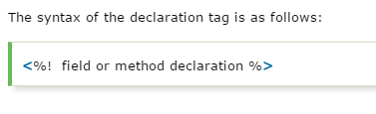

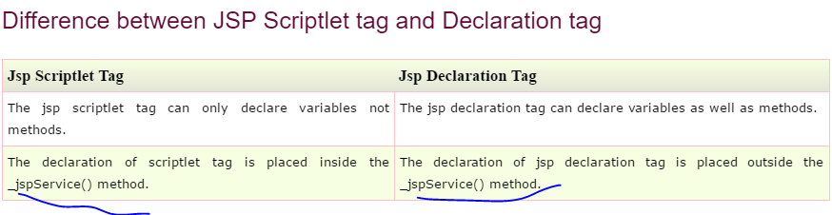



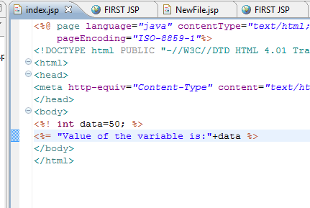

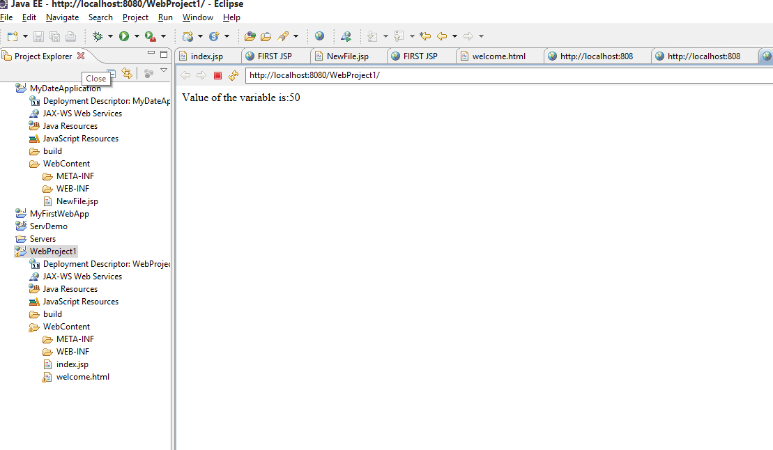

### **Example of JSP declaration tag that declares method->**

